**Module-4 Case Study**

1. **Created a VPC for production network**

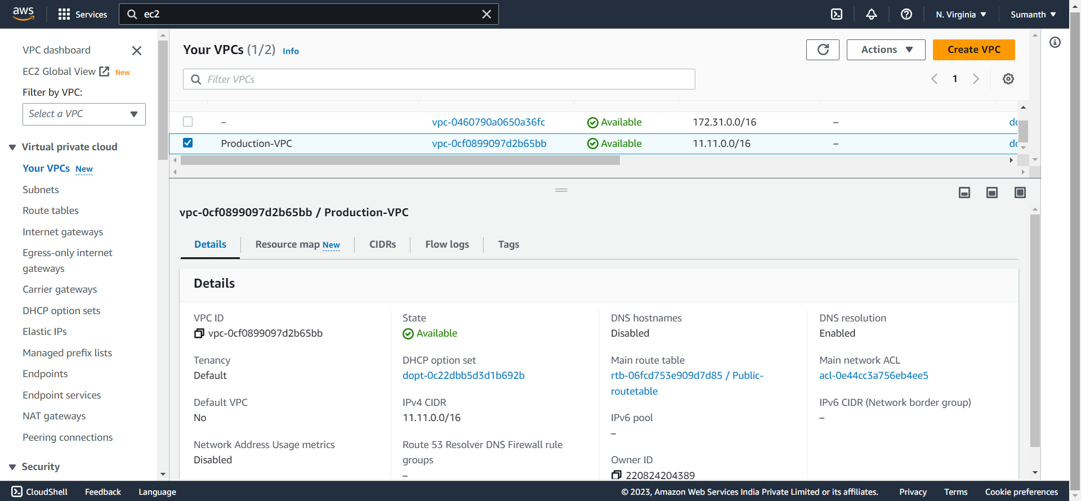

1. **Created subnets, made web as public by attaching IGW and remaining private.**

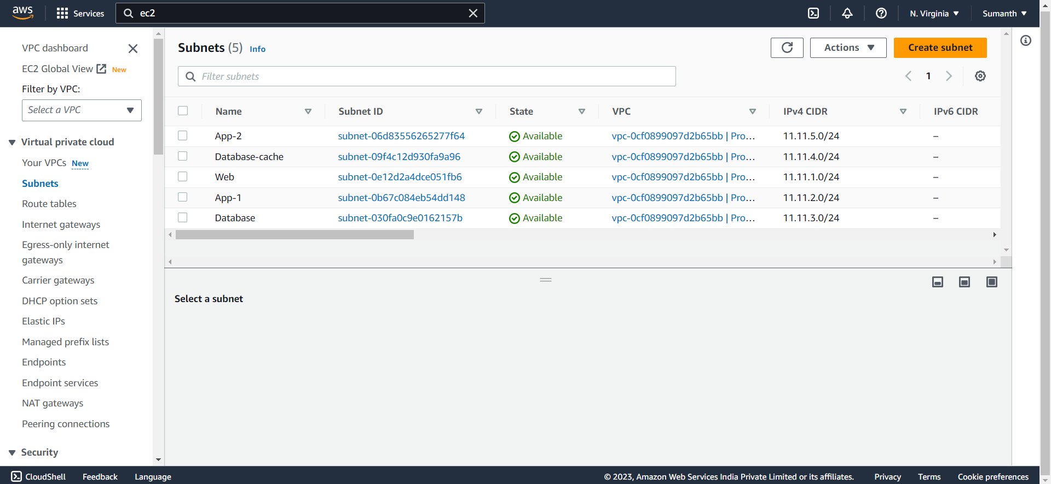

1. **Created route table to route IGW and NGW and associated with necessary subnets**

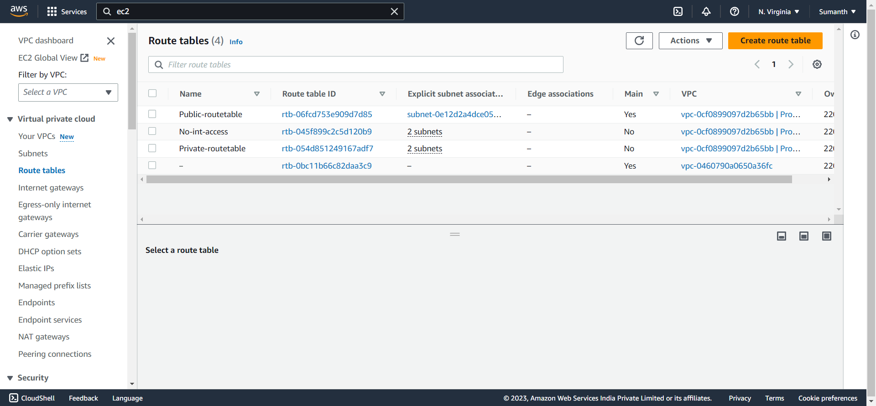

1. **Created IGW**

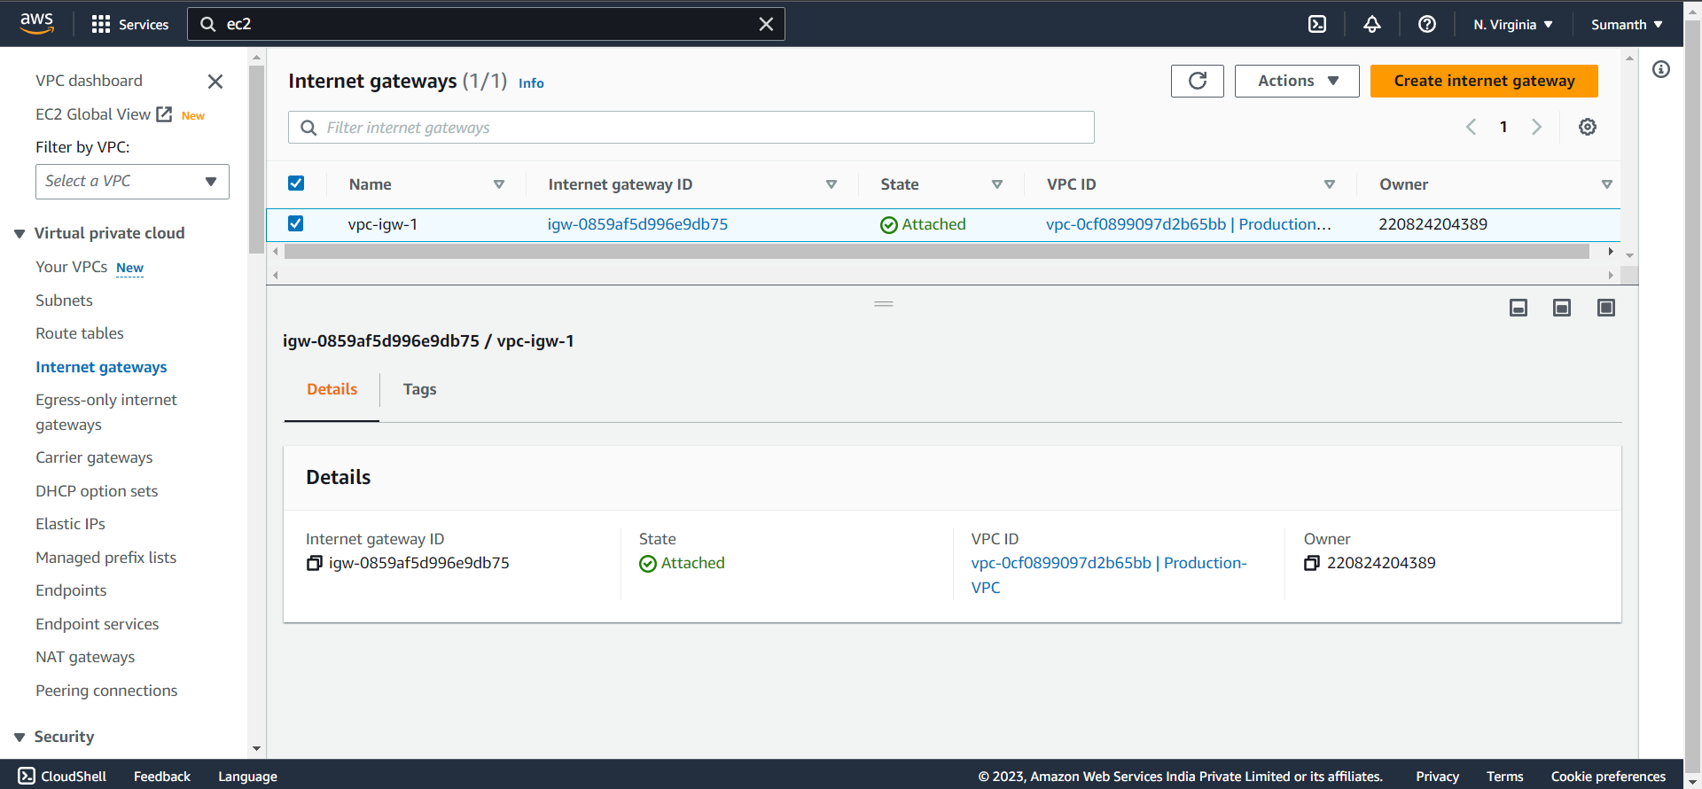

1. **Created NGW**

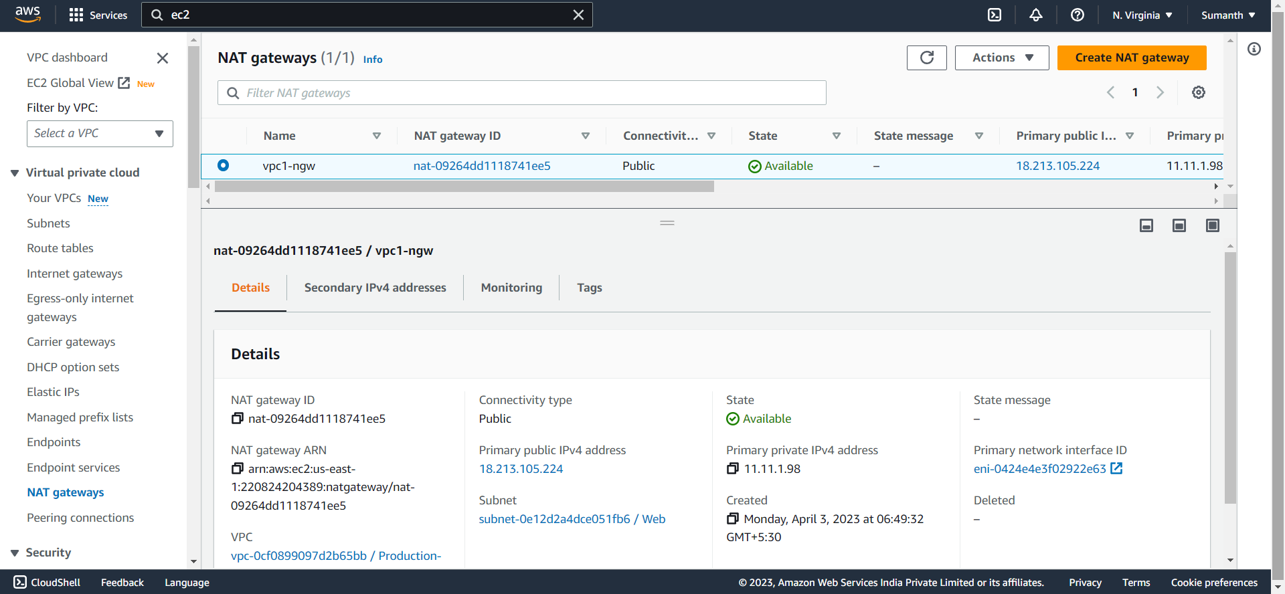

1. **Created the EC2 instance**

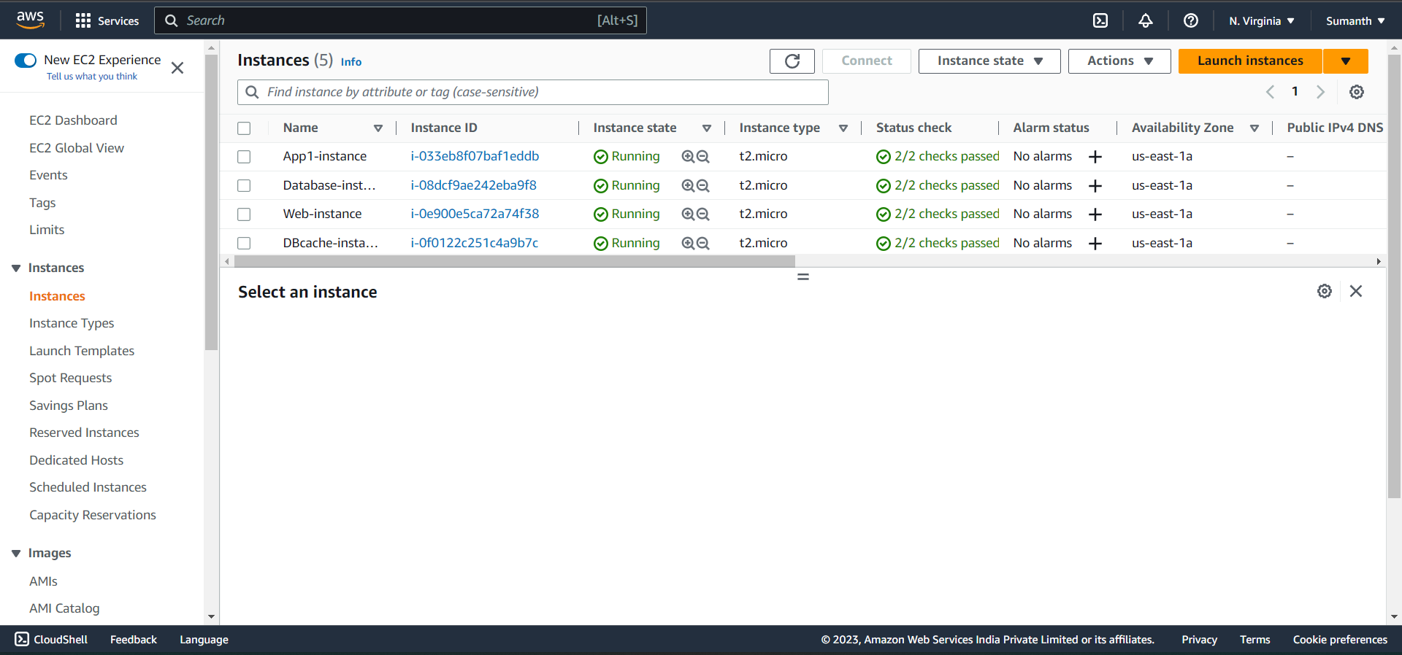

1. **Allowed App1 and Database cache instance to send internet requests**

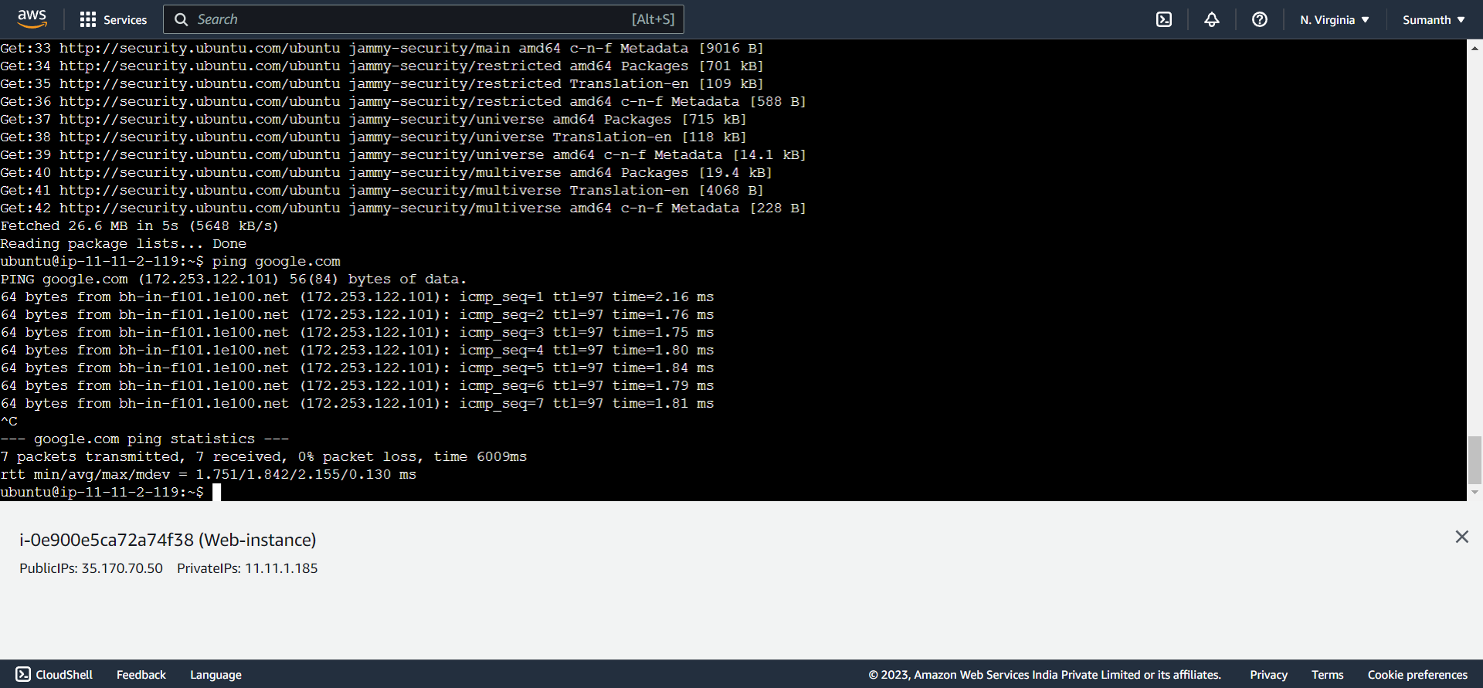

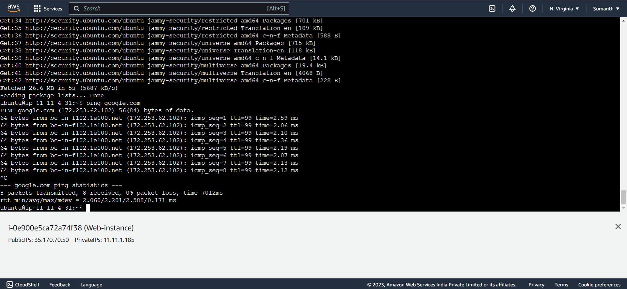

1. **Created a VPC for development network**

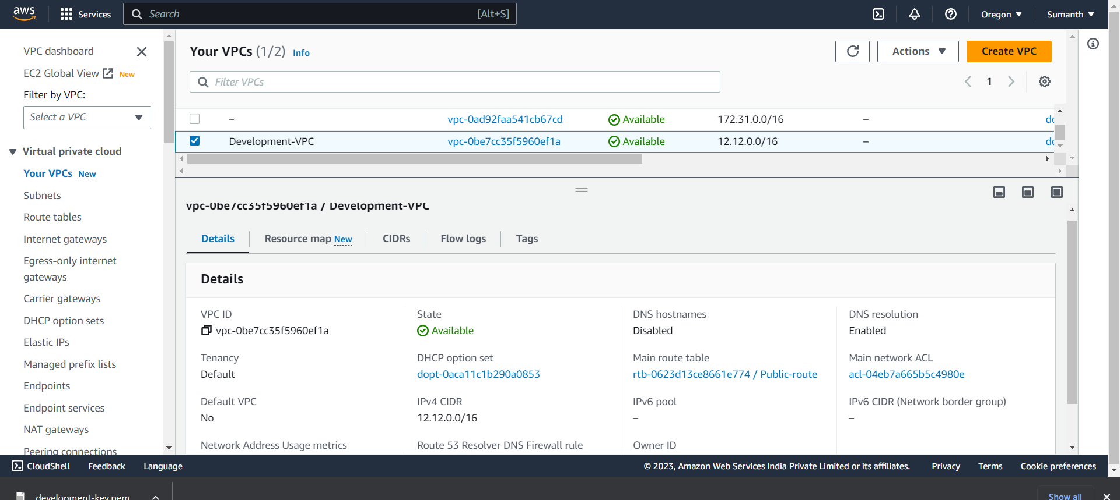

1. **Created 2 subnets in which Web subnet was connected to IGW**

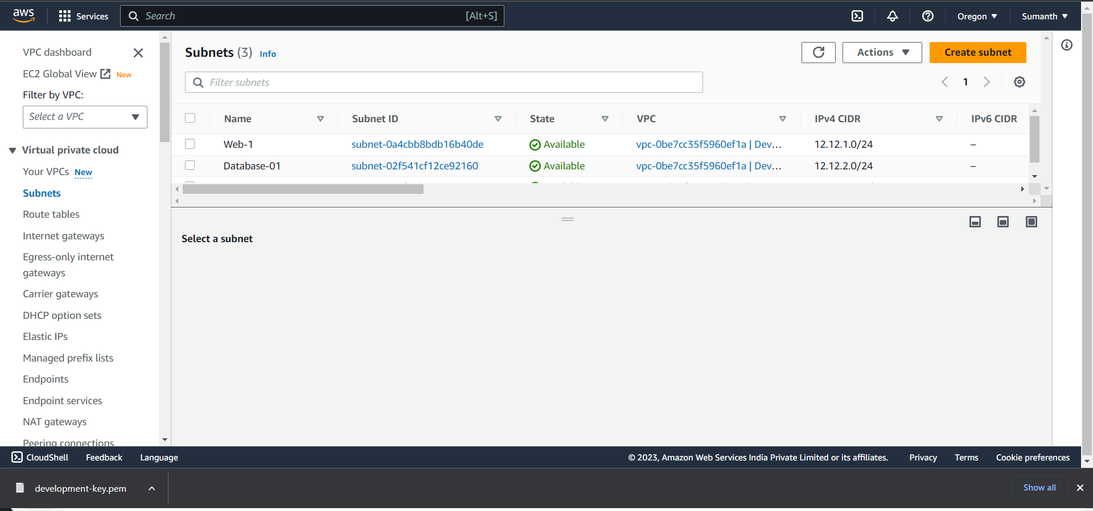

1. **Created route tables and associated with necessary subnets**

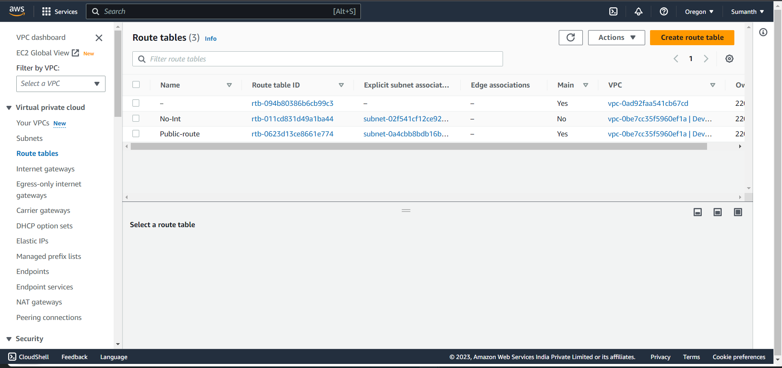

1. **Created IGW**

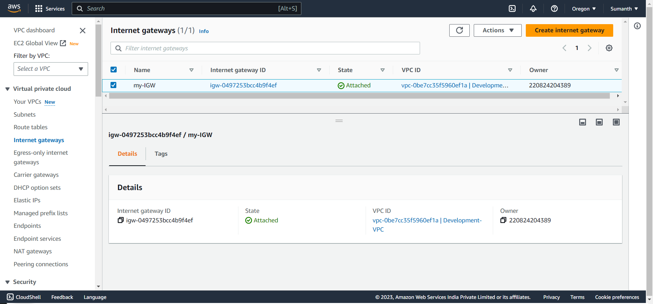

1. **Created a peering connection between both the VPC’s**

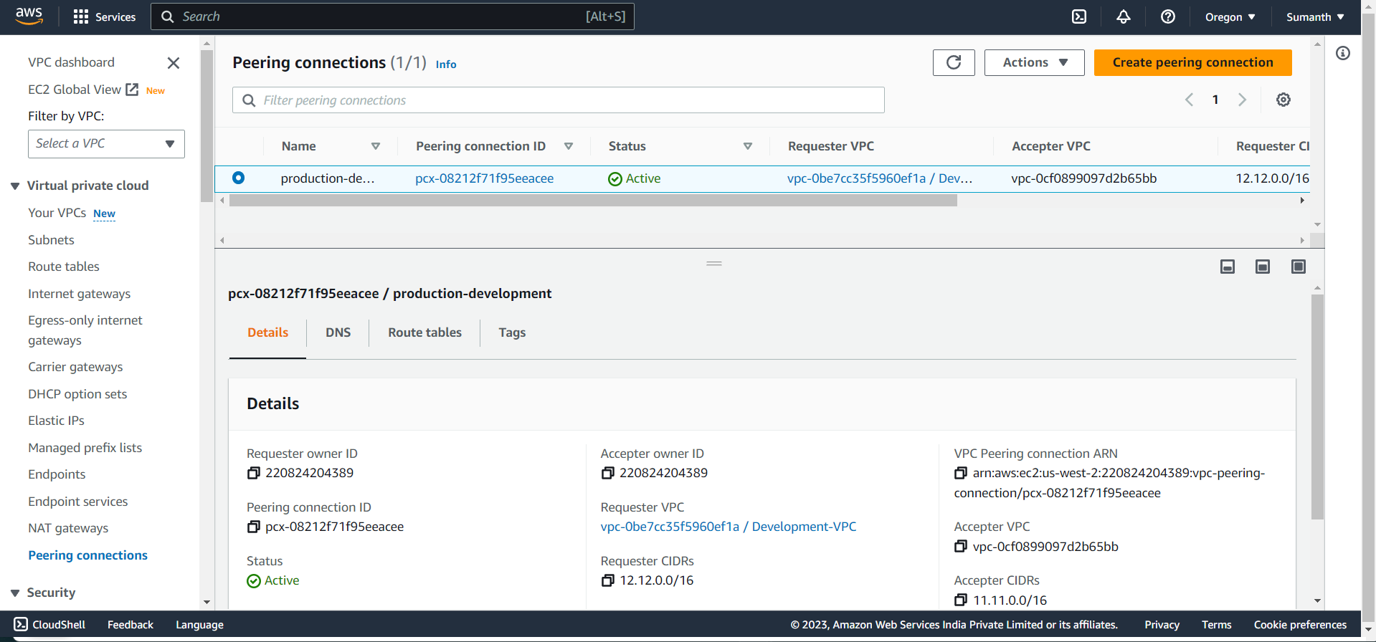

1. **Also mentioned the peering connection in both the VPC’s route table**

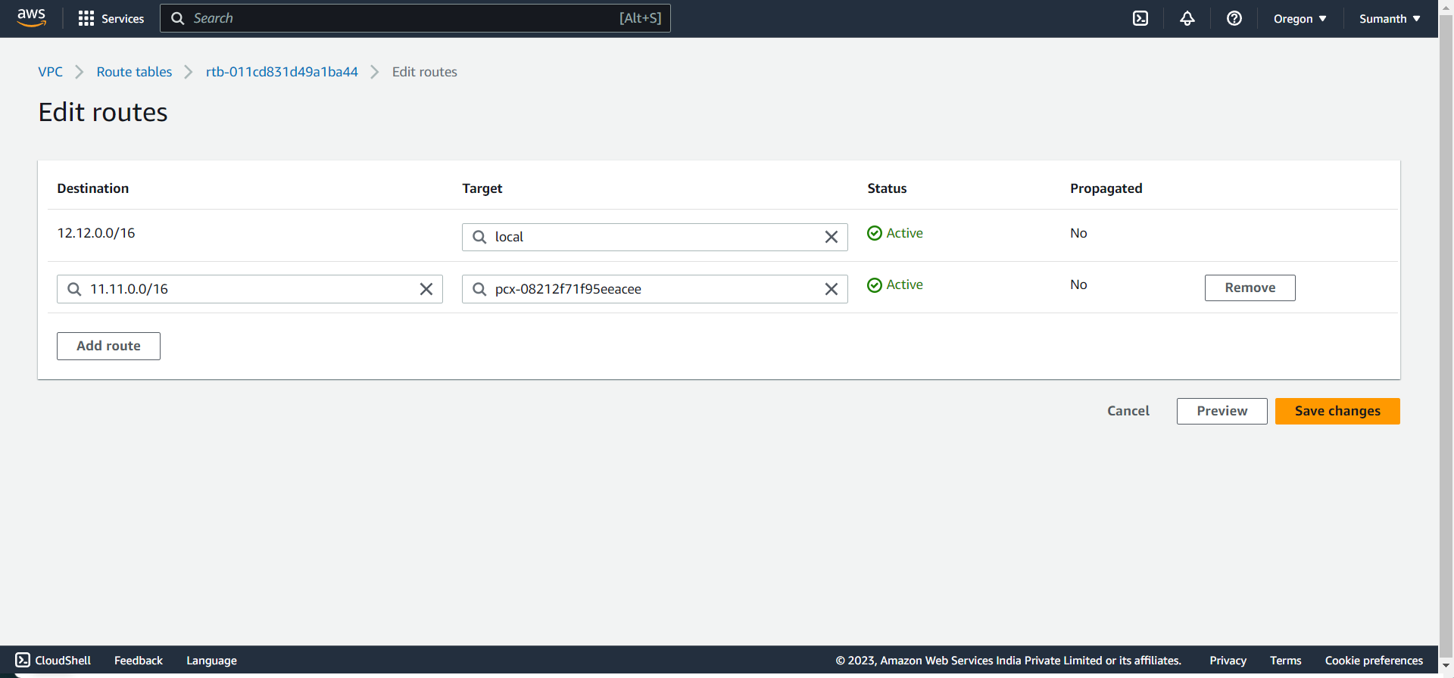

1. **Connection was successful between Database subnet of both the VPC’s**

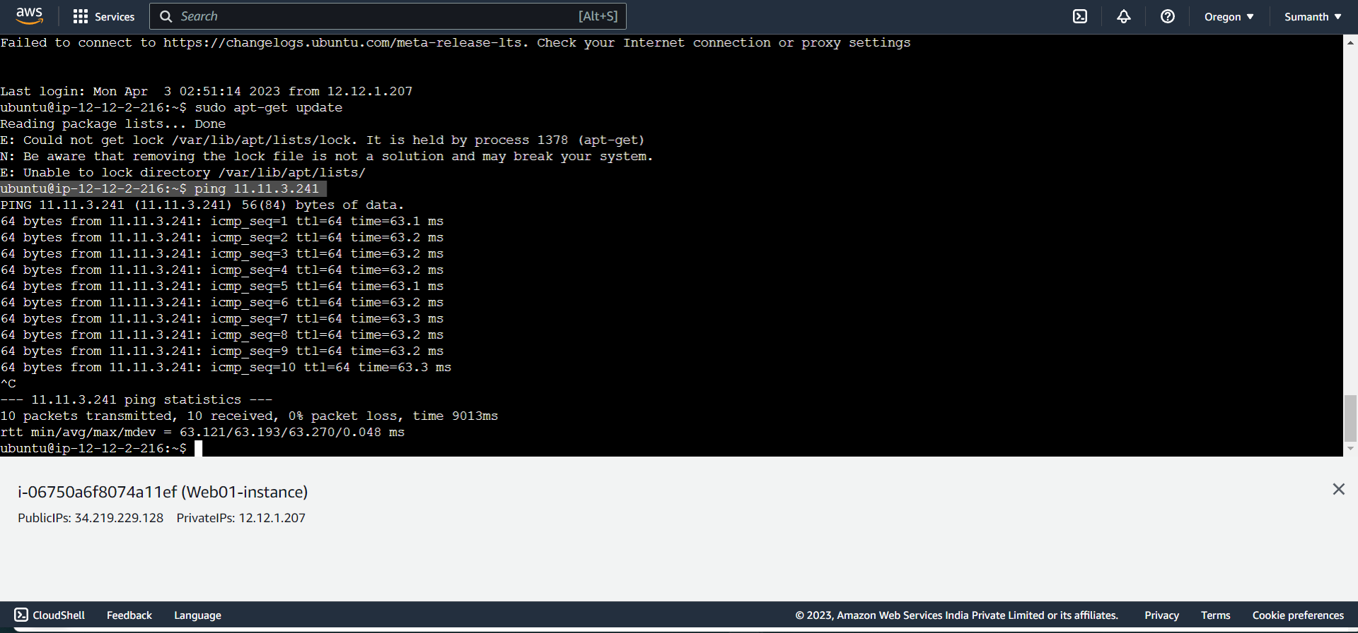

1. **Terminated all the services after the assignment**

**Thank you**